**ASSIGNMENT 3**

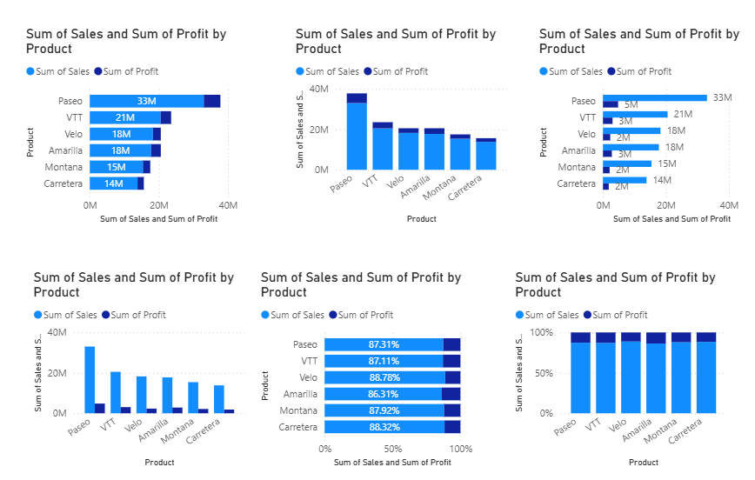

**COMPARISON BETWEEN STACKED, CLUSTERED AND 100% STACKED BAR CHART**

**STACKED BAR CHART**

* When we need to represent multiple categories like, sales profit, product etc. Stacked Bar Chart is best suitable option.
* It displays with more clarity and give clear view since the bars are in horizontal form.

**CLUSTERED BAR CHART**

* We can choose this type of chart when we need to show or compare the categories separately.
* Best suitable for comparing performance of the sub-categories.

**100% STACKED BAR CHART**

* To understand percentage wise distribution across categories, we can go for 100% Stacked Bar Chart.
* Best suitable when total size doesn’t matter, only proportion matter.

**COMPARISON BETWEEN STACKED, CLUSTERED AND 100% STACKED COLUMN CHART**

**STACKED COLUMN CHART**

* When we want to see overall totals and breakdown across categories we can go for Stacked Column Chart. It represents vertical columns stacked with sub-categories inside.

**CLUSTERED COLUMN CHART**

* When we want to compare sub-categories directly over categories, this chart is suitable.
* Here, vertical columns are placed side by side for each sub-category.

**100% STACKED COLUMN CHART**

* This chart represents proportion of sub-categories over categories. So in order to understand percentage wise distribution, this chart is best suitable.
* Vertical columns stacked, but scaled to 100%.

**STEPS FOR CONDITIONAL FORMATTING IN CHARTS**

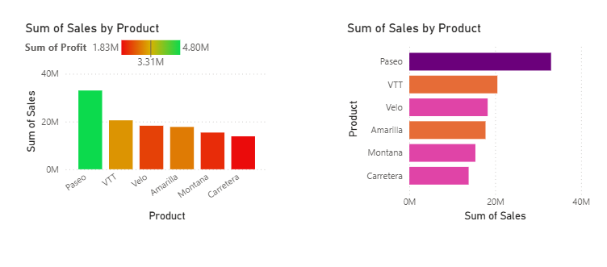

**CONDITIONAL FORMATTING IN COLUMN CHART USING GRADIENT FORMAT STYLE**

* Select the chart where formatting needs to be applied
* Add fields to the chart.
* In visualisation pane, click on format icon.
* Click on bar/column option.
* Next to colour heading, click the ***Fx***(Conditional Formatting) button. Colour category page opens. Choose colour scale🡪 Gradient.
* Choose the field in which we want to show the categories. Click on drop down menu🡪All data🡪Choose the field e.g. profit.
* Select the format empty value🡪Don’t Format option
* Set the suitable colour from more colour option for setting the minimum, centre and maximum values. Click on ok button.
* All the adjustments will be reflected on the selected chart(stacked column chart).

**CONDITIONAL FORMATTING IN BAR CHART USING RULES FORMAT STYLE**

* Choose Rules option from Format by dropdown when we need to highlight values based on ranges. ( E.g. if value >= and <= the specified number).
* Set the condition or range and choose the colour. Click on add new rules button for setting number of conditions.
* Then Click on ok.

**STEPS TO INSERT FILTERS IN COLUMN CHART**

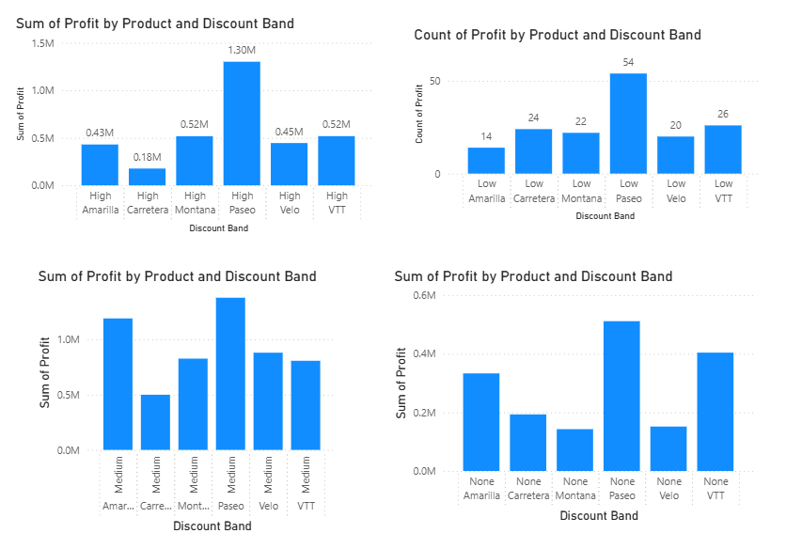

1. Select the chart which need to be filtered.
2. Drag the field into X axis for example Discount band
3. Click on filter pane.
4. Click on Discount band drop down and choose different filter types( High, Low, Medium, None) to represent the variation.

**USE OF SMALL MULTIPLES**

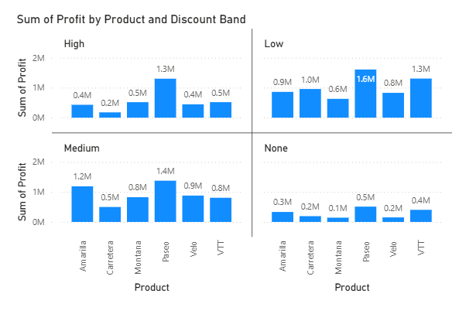

We can use Small Multiples option when we want the same chart repeated per category, for easy comparison without mixing all categories in one chart. For e.g. drag Discount Band from Data pane to Small Multiples field which will split the chart giving clear side by side views.